Flatterning Json data

1. Dataset 1=emp_details_0:

{"id":101,"name":"srinivas","gender":"male","language":"english","location":"hyderabad"}

Upload json file in adls

* Now go to data factory->dataflow
* Create new dataflow
* Add source->add dataset 1
* 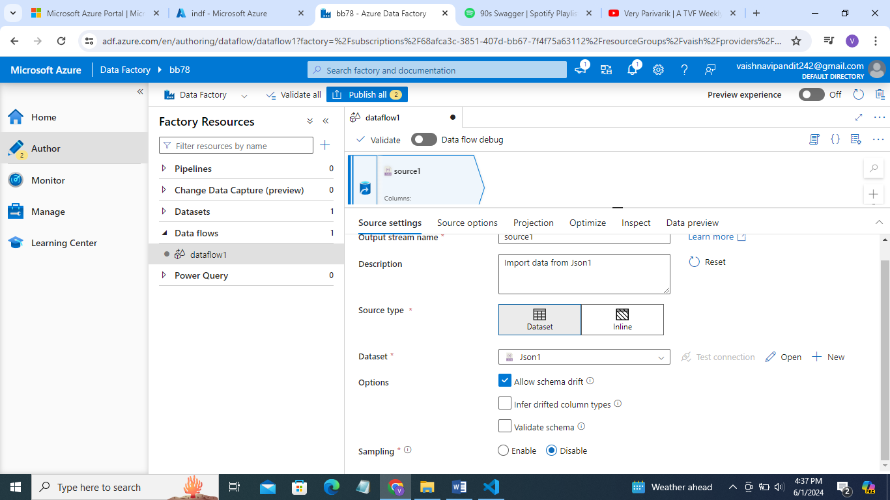
* See preview the data is converted in rows and column

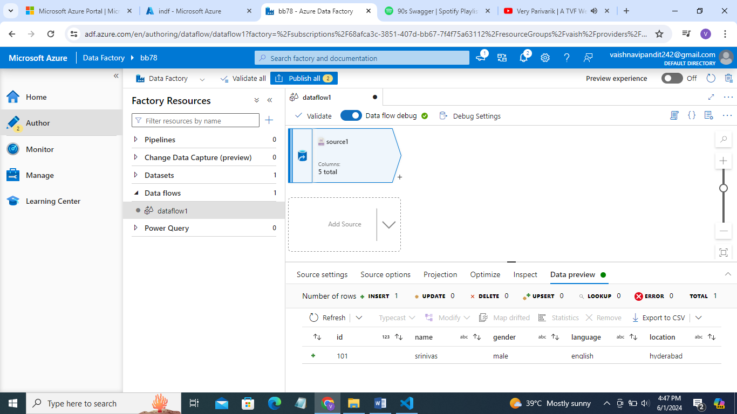

* Now add sink dataset while adding datset don’t select json select csv

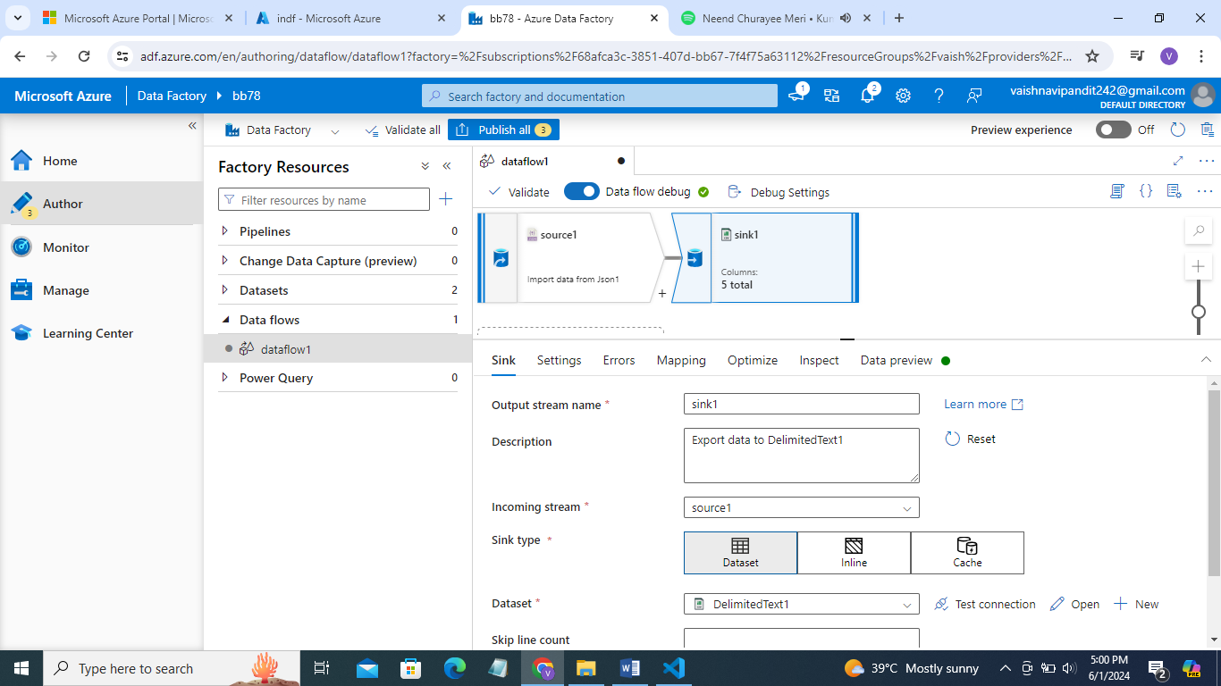

* Now create pipline for dataflow and add this dataflow to it

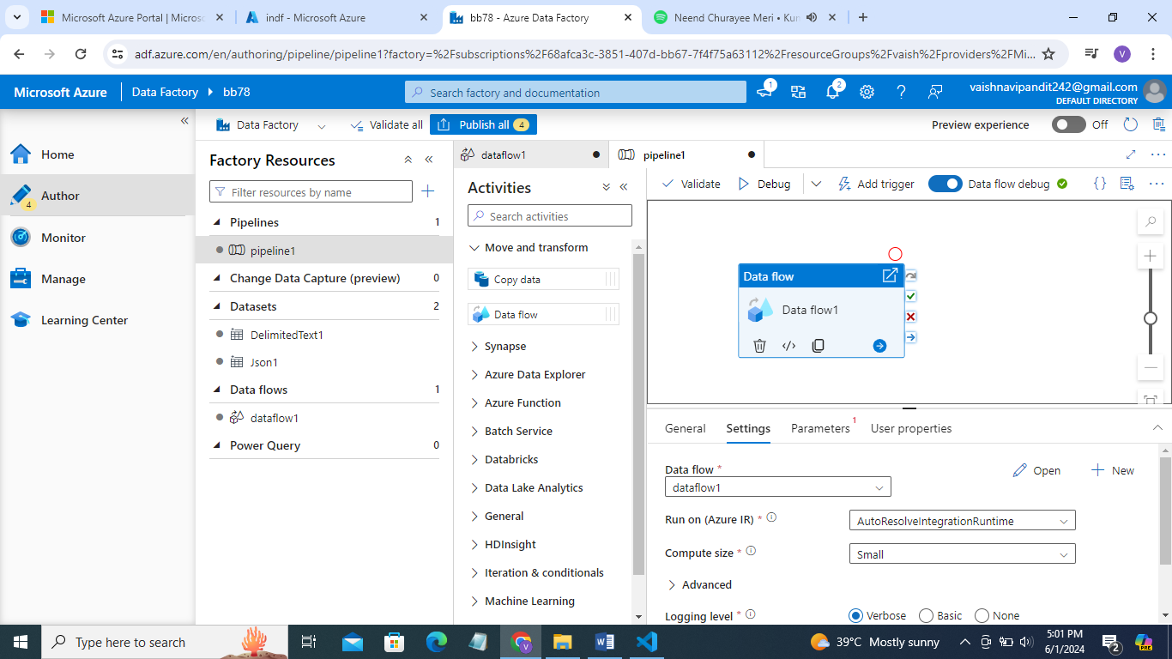

* Now debug
* See this file dowmloaded from the adls sink folder

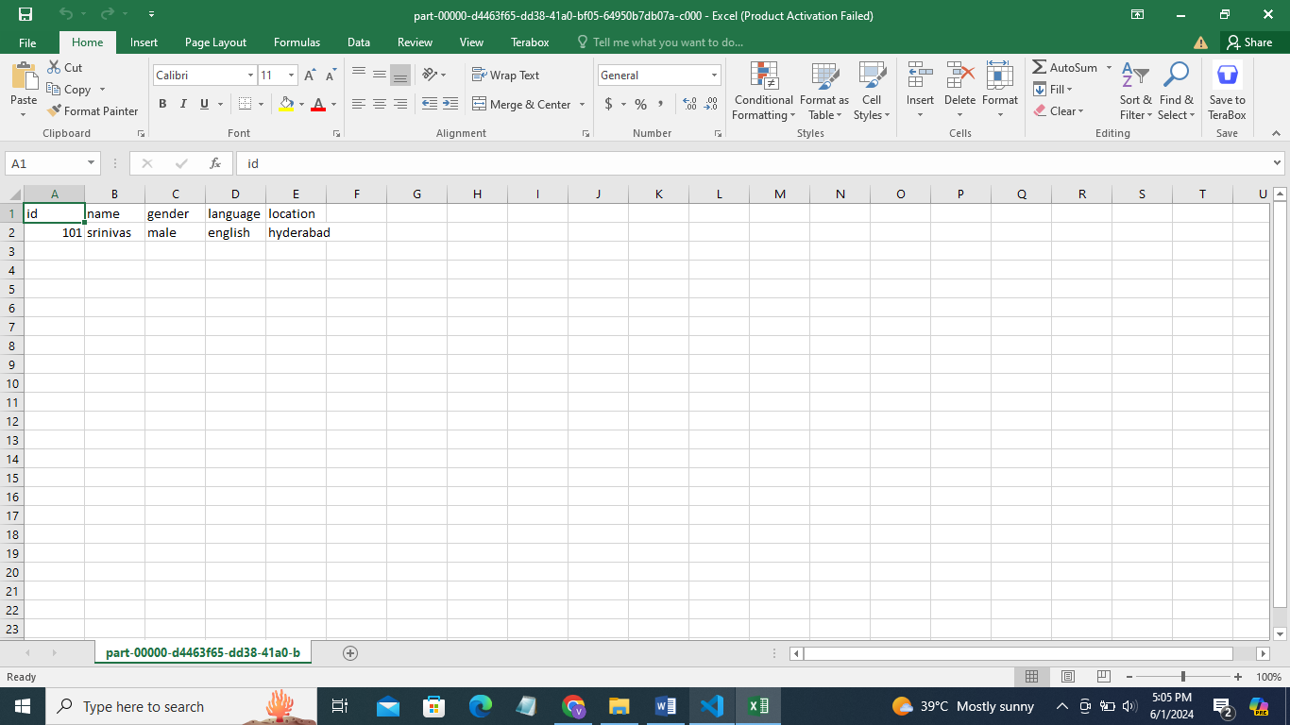

This is how json data is flatterned and converted into csv we can convert it to sql table aslo just need to add sql table in sink dataset